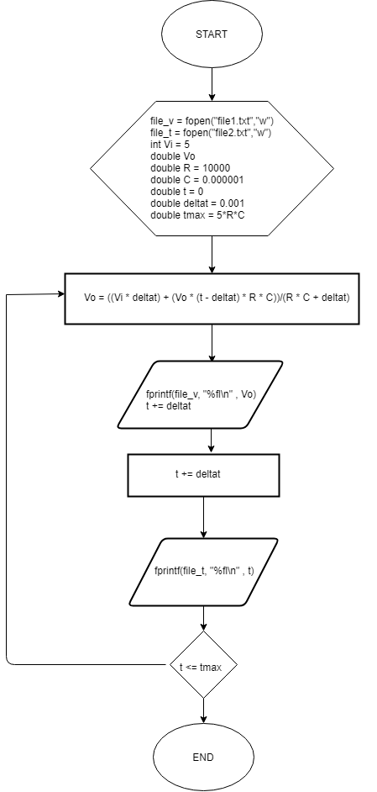Putri Yulianti Suhayat

18318004

x = t ; y = V(t)

